**Employee App Report**

**Name**: Yixuan Li

**Content**:

1 Introduction 2

1.1 Implementation Technique 2

1.1.1 MATLAB 2

1.1.2 App Designer 2

1.2 Application of Technology 2

2 Development Tool and Environment 2

2.1 Software Tools 2

2.2 Environment 2

3 System Analysis and Design 2

3.1 Requirements analysis 2

3.2 Use Case Diagram 3

3.3 Data Flow Analysis 3

3.4 Object Diagram 4

3.4.1 Model 4

3.4.2 View 4

3.4.3 Controller 5

3.5 Sequence Diagram 5

4 System Implementation 5

4.1 Function Implementation 5

4.2 Graphical User Interface 5

5 Testing 5

6 Summarization 6

6.1 Summarization 6

6.2 Prospect 6

6.3 Puzzles 6

# 1 Introduction

## 1.1 Implementation Technique

### 1.1.1 MATLAB

MATLAB combines a desktop environment tuned for iterative analysis and design processes with a programming language that expresses matrix and array mathematics directly.

* Professionally Built

MATLAB toolboxes are professionally developed, rigorously tested, and fully documented.

* With Interactive Apps

MATLAB apps let you see how different algorithms work with your data. Iterate until you’ve got the results you want, then automatically generate a MATLAB program to reproduce or automate your work.

### 1.1.2 App Designer

* Simplifies the process of laying out the visual components of a user interface. It includes a full set of standard user interface components, as well as a set of gauges, knobs, switches, and lamps.
* Integrates the two primary tasks of app building – laying out the visual components and programming app behavior.
* Useful align and indent editor

## 1.2 Application of Technology

* Engineering new solution
* Working with linear algebra
* Performing numerical analysis

# 2 Development Tool and Environment

## 2.1 Software Tools

* App designer
* MATLAB R2018b

## 2.2 Environment

* Operating system: 64-bit(windows)
* RAM: 64.0 GB
* Processor: x64-based

# 3 System Analysis and Design

## 3.1 Requirements analysis

1. Code documentation
   * Good for maintaining and readability
2. Apply Model-View-Controller architecture
   * Lower the coupling. Modification does not affect the entire model
   * Faster development process. MVC supports rapid and parallel development.
   * In the MVC Model, you can create multiple views for a model. Code duplication is very limited in MVC because it separates data and business logic from the display. The code is easier to re-use and independently test
3. Input validation

- A non-empty, alphabetic character only name

- A 4-digit phone number extension, such as 7794

1. clean and concise organization of code

* Limit the duplicated code, reuse the code by putting the same block of code inside one function
* Apply object-oriented principal while designing the data structure

## 3.2 Use Case Diagram

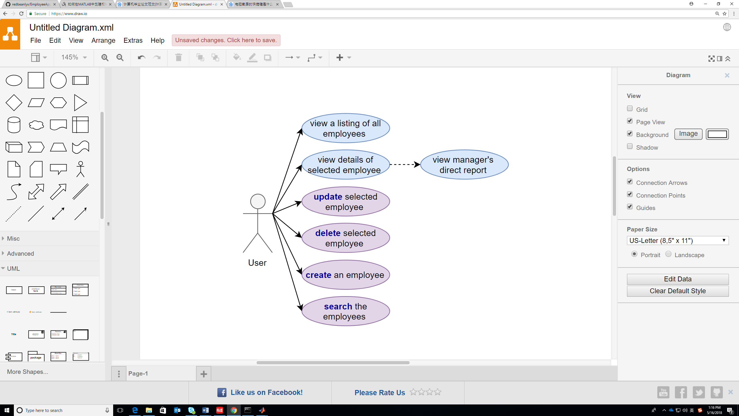

## 3.3 Data Flow Analysis

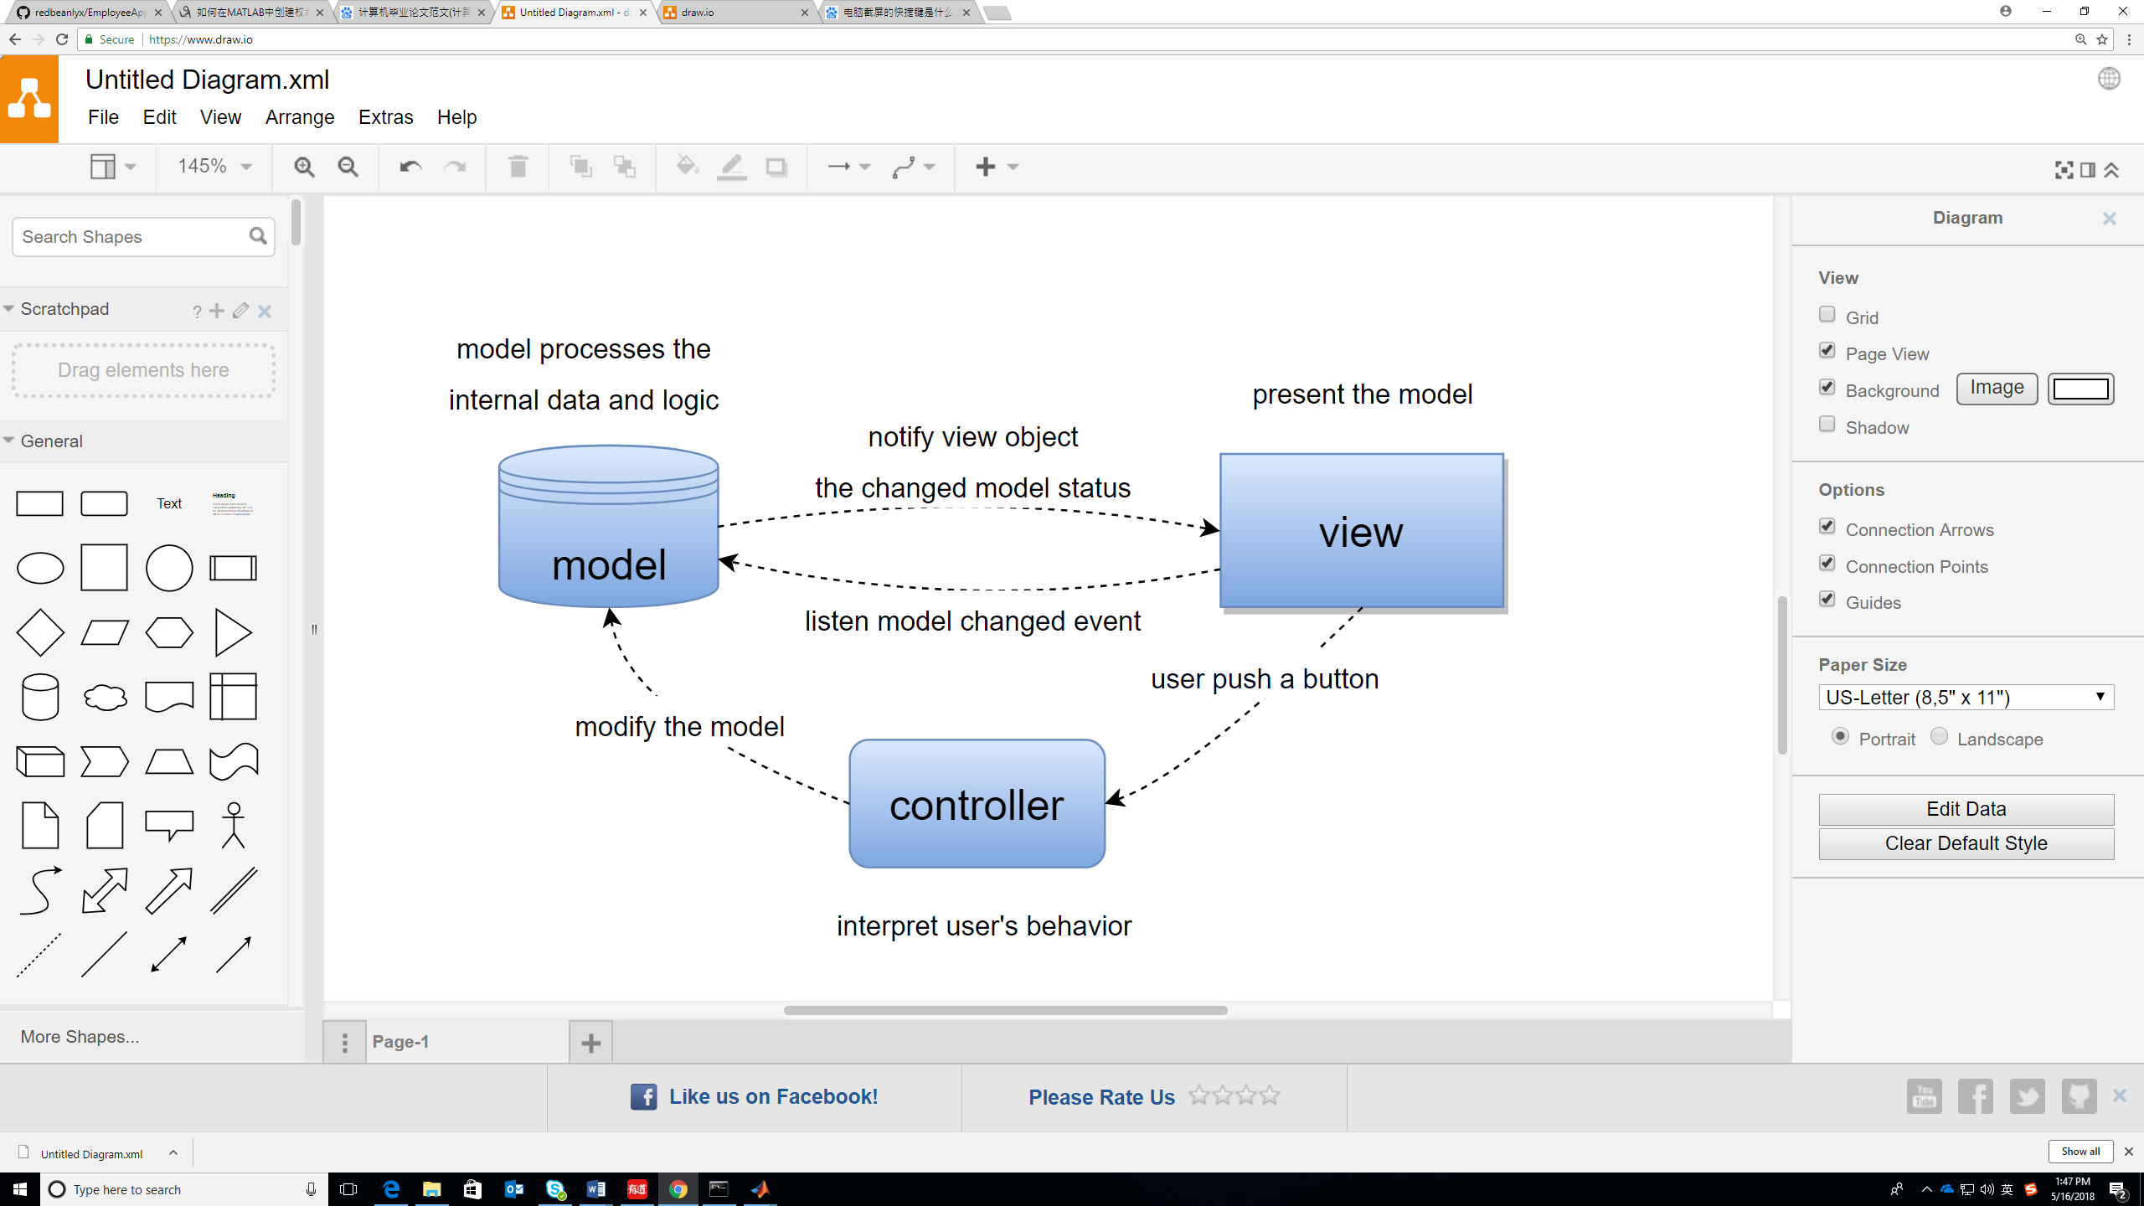

## 3.4 Object Diagram

### 3.4.1 Model

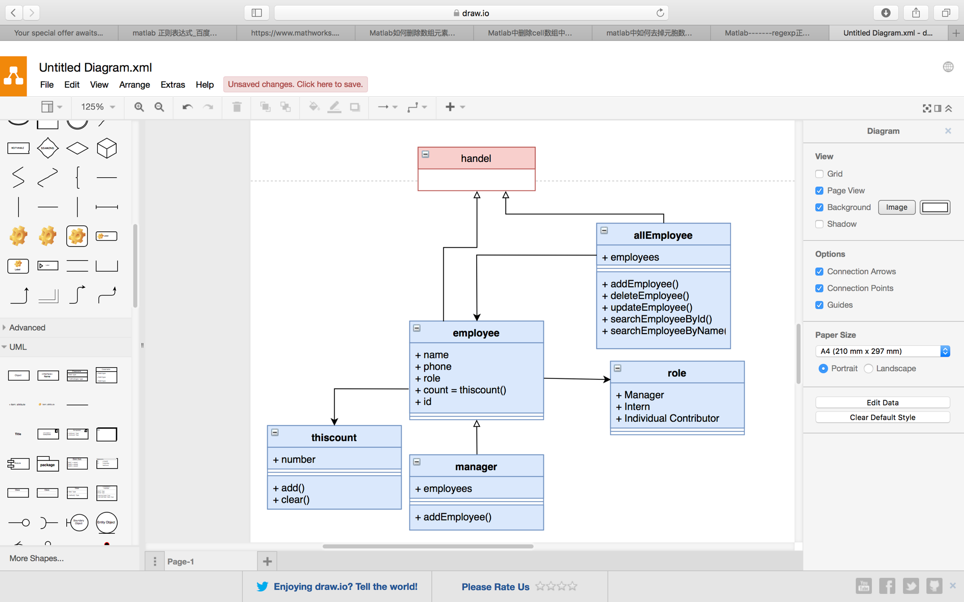

### 3.4.2 View

Each of the view class has two additional properties: modelObj and controllerObj

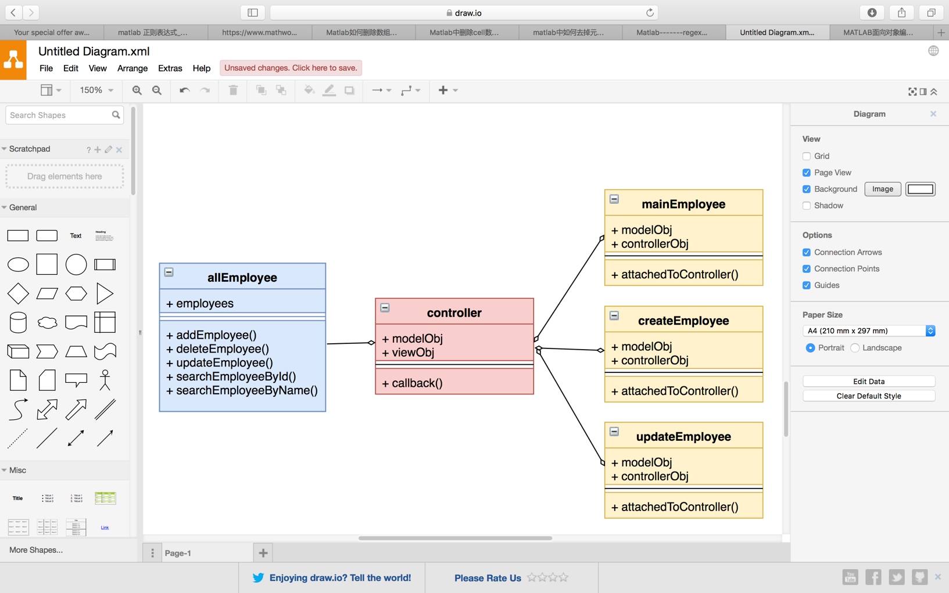

### 3.4.3 Controller

Each of the view class has two additional properties: modelObj and viewObj

## 3.5 Sequence Diagram

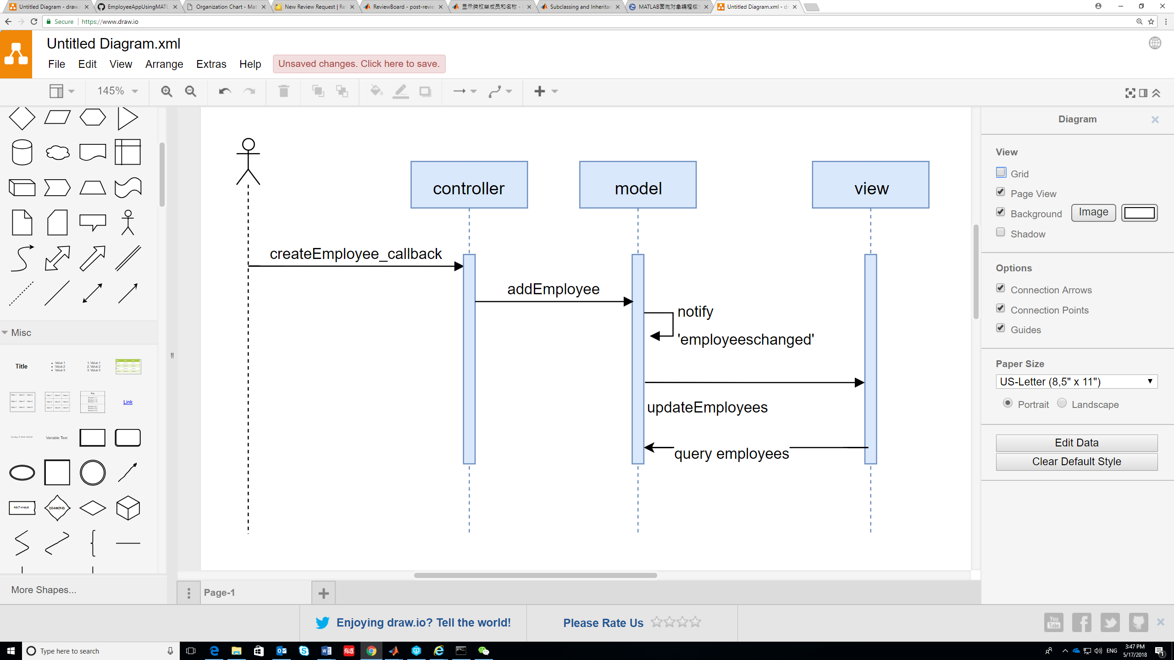

# 4 System Implementation

## 4.1 Function Implementation

## 4.2 Graphical User Interface

# 5 Testing

Everything looks great!

# 6 Summarization

## 6.1 Summarization

* MATLAB syntax
* Generate object-oriented code by using app designer

## 6.2 Prospect

* Connect to the database to persist the data
* Upload profile photo

## 6.3 Puzzles

* What is the naming convention in our team?
* Couldn’t modify the constructor in app designer directly
* Couldn’t Open *.m file in app designer
* How to design the MVC architecture?
* MATLAB doesn’t support ‘++’ operator
* When create class, it may be better if allowing us to type the class’s name first
* Is it a good practice to divide the Code into different package? (view-model-controller-service…)
* Arguments such as app, obj are really easy to forget for beginners
* Lack auto completion of code
* When redirect to the line contains error, it is better to highlight the line (use red color background)
* Windows opened slowly
* Use get() and set() function
* Where to put the validation function is the most ideal?